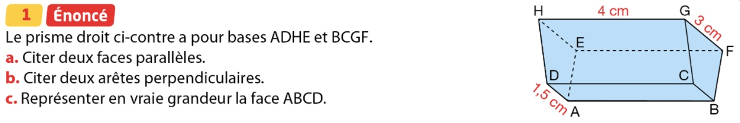

|  |  |
| --- | --- |
| /Users/Bachir/Documents/PREP 5/5/2.jpeg  /Users/Bachir/Documents/PREP 5/5/3.jpeg  /Users/Bachir/Documents/PREP 5/5/4.jpeg  /Users/Bachir/Documents/PREP 5/5/6.jpeg  /Users/Bachir/Documents/PREP 5/5/8.jpeg  /Users/Bachir/Documents/PREP 5/5/6.jpeg  /Users/Bachir/Documents/PREP 5/5/8.jpeg |  |
|  |  |
|  |  |